**A REPORT SUBMITTED AS A PART OF EXPERIENTIAL LEARNING ON SEAM**

# TOPIC : Employee Management Systems

# Description: CGU ODISHA (@CguOdisha) | Twitter

# Under the Supervision of Professor

# Mrs. Chandan Kumar Panda

## Submitted By

|  |  |
| --- | --- |
| **GROUP-10** | |
| **NAME** | **REGD. NO** |
| **AAKASH BURNWAL**  **SHREAYA KUMARI**  **SAURAV KUMAR**  **RANA SUJIT KUMAR**  **MAHENDRA SINGH** | **2101020279**  **2101020282**  **2101020305**  **2101020306**  **2101020451** |

## CONTENT

1.Introduction 3

2. Key Features of Employee Management Systems 3

3. Implementation 4

4. Output 7

5. Database 8

6. Conclusion 9

## INTRODUCTION

In today's fast-paced and competitive business landscape, organizations are recognizing the critical importance of effective human resource management. Employee Management Systems (EMS) have emerged as indispensable tools for businesses seeking to optimize their HR operations. These systems encompass a range of functionalities aimed at streamlining HR processes, enhancing employee productivity, and fostering a positive work environment. This report delves into the significance, features, types, implementation considerations, benefits, challenges, case studies, and future trends of Employee Management Systems.

Effective management of human resources is fundamental to organizational success. Employee Management Systems play a pivotal role in achieving this goal by providing centralized platforms for handling various HR tasks. From recruitment and onboarding to payroll processing and performance evaluation, EMS automate and streamline critical HR functions, allowing organizations to focus on strategic initiatives and core business objectives. By leveraging EMS, companies can ensure compliance with labor laws, improve workforce productivity, and cultivate a culture of employee engagement and satisfaction. Top of Form

Top of Form

**Key Features of Employee Management Systems**

Employee Management Systems offer a wide array of features designed to meet the diverse needs of modern organizations. Some of the key features include:

Payroll Processing: Automated calculation and disbursement of employee salaries, taxes, and benefits.

Time and Attendance Tracking: Monitoring employee attendance, leave, and working hours to ensure accuracy and compliance.

Employee Self-Service Portals: Empowering employees to access and manage their personal information, submit leave requests, and view pay stubs.

Performance Evaluation and Management: Conducting performance reviews, setting goals, and tracking employee progress to facilitate professional growth and development.

Benefits Administration: Administering employee benefits such as healthcare, retirement plans, and insurance.

Compliance Management: Ensuring adherence to labor laws, regulations, and company policies.

Reporting and Analytics Tools: Generating insights and reports on various HR metrics to support data-driven decision-making.

Increased Efficiency: Automation of routine HR tasks reduces manual effort and minimizes errors, leading to greater operational efficiency.

Cost Savings: By streamlining processes and eliminating paper-based workflows, EMS help reduce administrative costs and improve resource utilization.

**Implementation**

When implementing an Employee Management System, organizations should consider several factors to ensure successful deployment and adoption:

Scalability: The EMS should be capable of accommodating the organization's current needs and future growth.

Integration Capabilities: Seamless integration with existing systems, such as accounting software and HRIS (Human Resource Information System), is essential to avoid data silos and streamline processes.

Customization Options: The ability to customize the EMS to align with the organization's unique workflows and requirements enhances usability and effectiveness.

User-Friendliness: Intuitive user interfaces and comprehensive training programs are crucial for ensuring smooth adoption and acceptance by employees.

Security Measures: Robust data security measures, including encryption, access controls, and regular audits, are necessary to safeguard sensitive employee information and ensure compliance with data protection regulations.

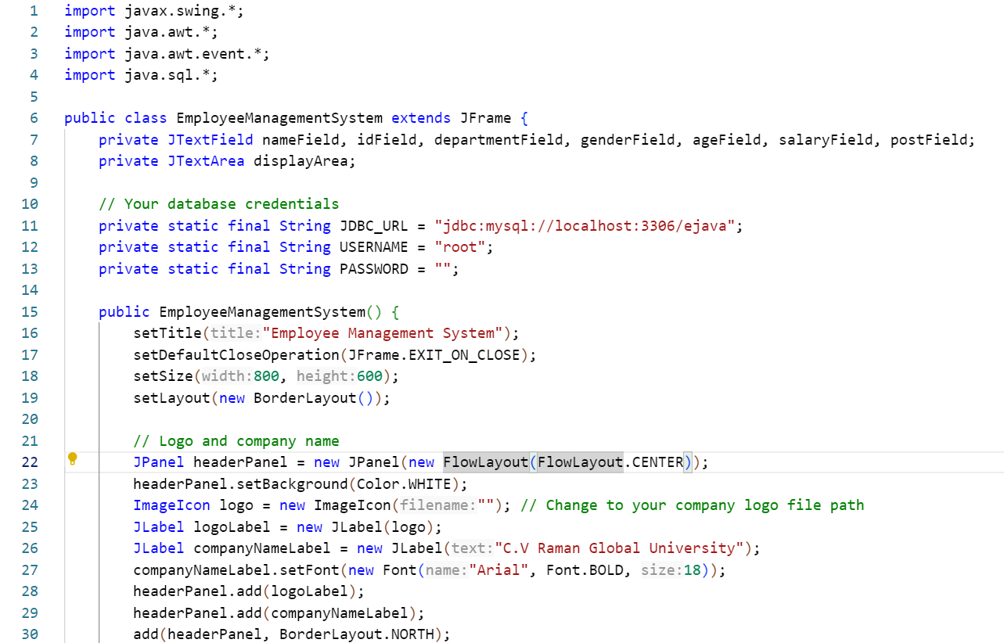

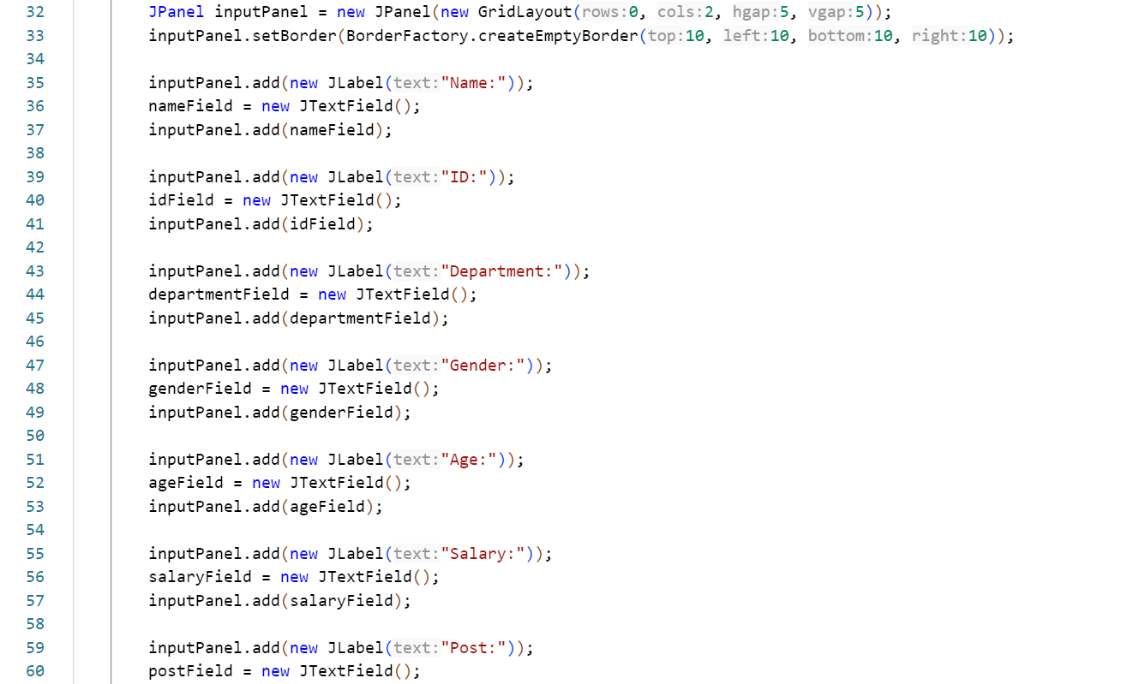

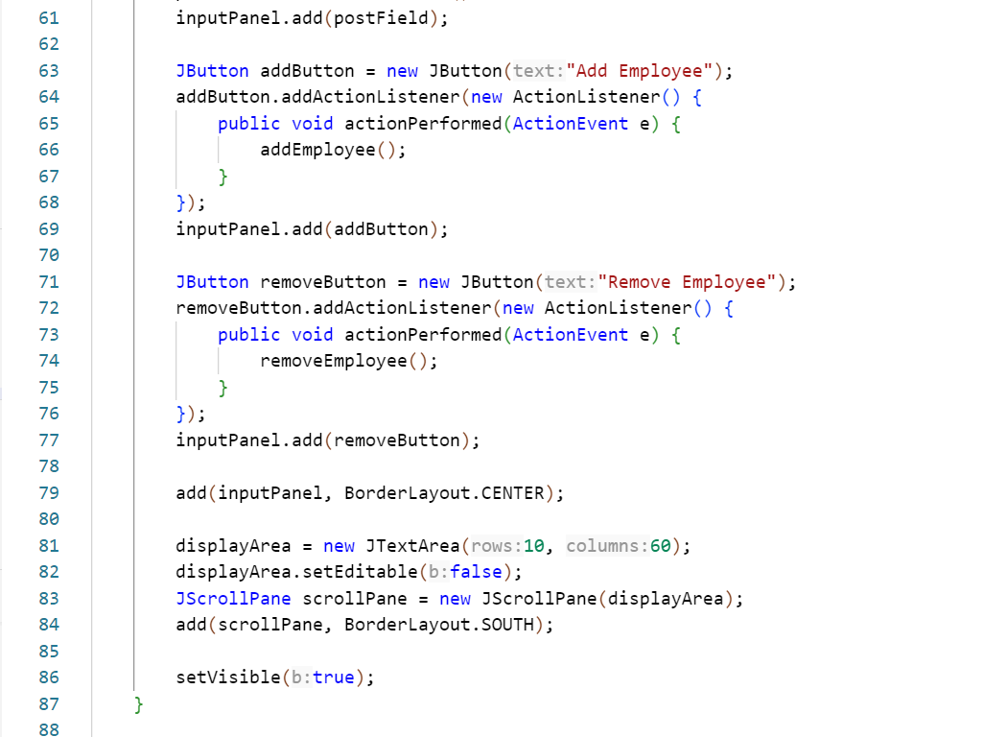

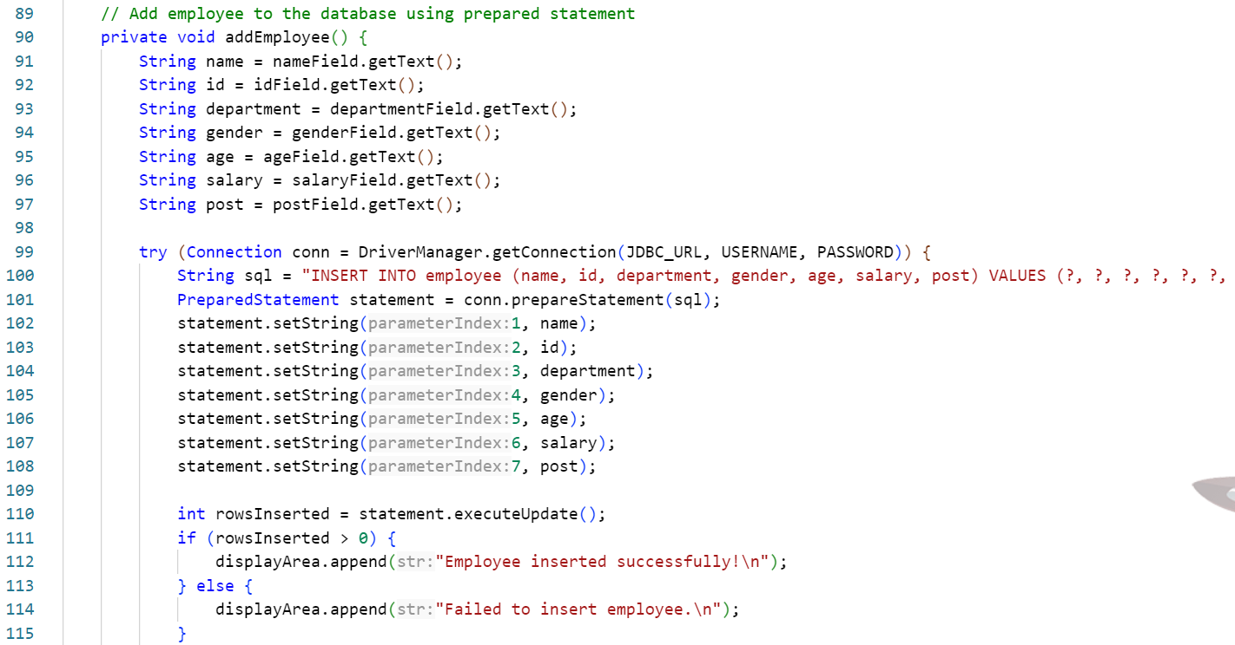

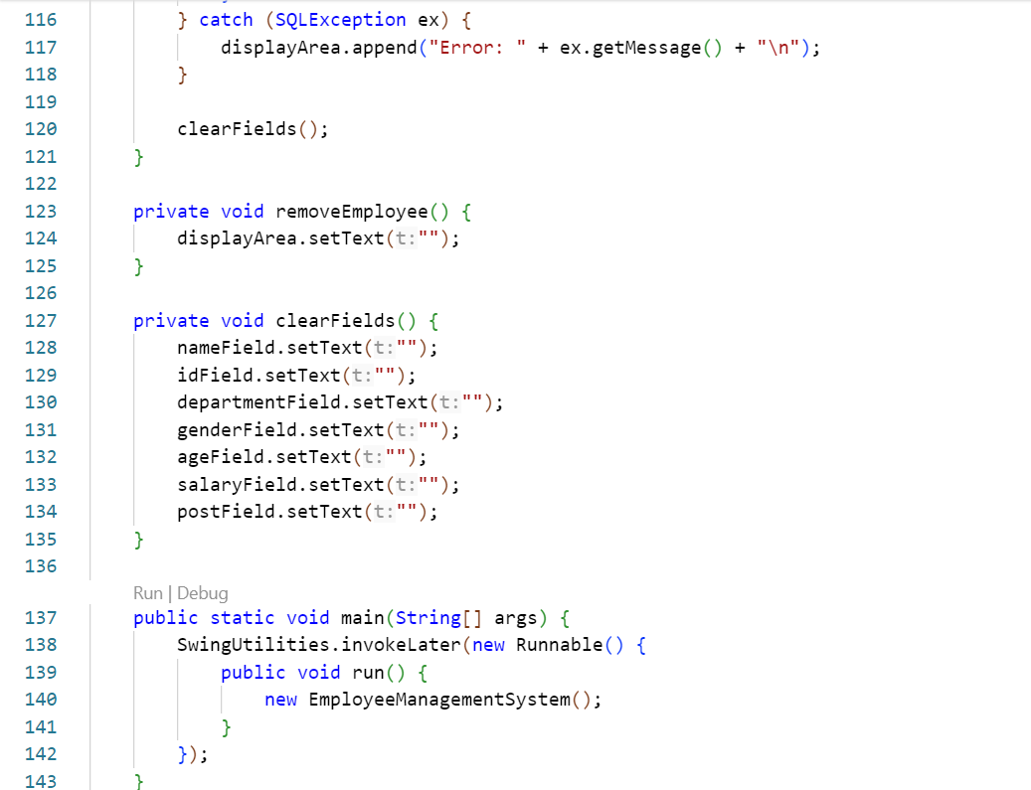

**Output:**

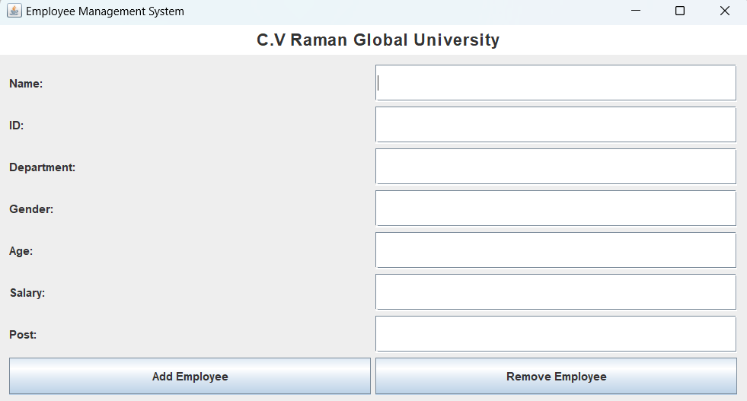

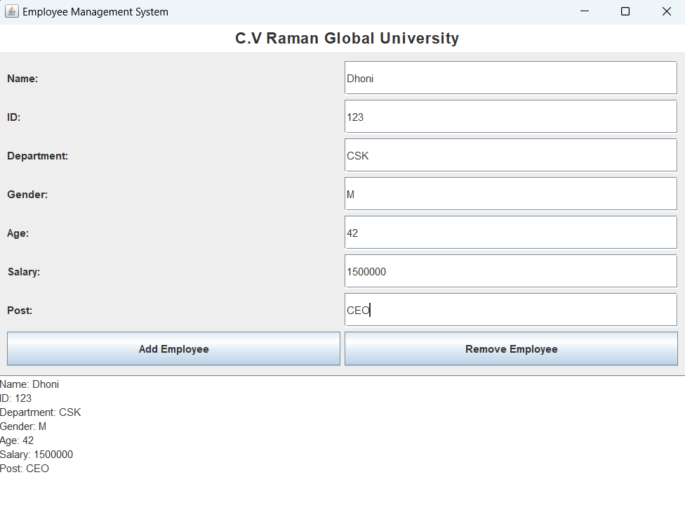

**DATABASE CONNECTION**

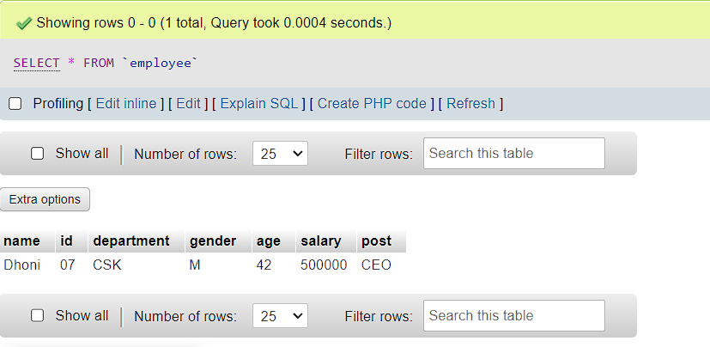

**Conclusion**

Employee Management Systems (EMS) represent a pivotal advancement in modern HR practices, offering organizations a comprehensive solution to optimize workforce management. By automating routine tasks, streamlining processes, and providing valuable insights through analytics, EMS contribute significantly to operational efficiency, compliance, and employee satisfaction. The diverse range of features, including payroll processing, performance management, and self-service portals, underscores the versatility and effectiveness of EMS in addressing the multifaceted needs of today's businesses. Despite challenges such as resistance to change and data security concerns, proactive strategies and robust implementation approaches can mitigate these obstacles. Looking ahead, the future of EMS is poised to be shaped by emerging trends such as artificial intelligence and mobile accessibility, further enhancing their functionality and impact. As organizations continue to navigate evolving workforce dynamics, EMS will remain indispensable tools for driving organizational success and fostering a positive work environment.